**GROUP MILESTONE- 2**

**PROJECT NAME:** PanVac Project

**GROUP NAME:** Group 1

**GROUP MEMBERS:** Sreejaya Parameswaran - SXP190110

Debshila Bhattacharya- DXB200002

Mariya Khalid -MXK153530

Lakshit Rajput- LXR190004

Prabhavi Soni - PXS190071

Meenal Badki - MHB180001

Executive Summary

The biggest discussion point currently across the world since March 2020 has been around the spread of the Coronavirus, also known as COVID-19. The discussion used to be about how to contain the virus and prevent the spread of positive cases, but now everyone’s main focus is the schedule of the vaccine rollouts. More specifically, people want to know when they can get the vaccine for themselves and their loved ones. This is something residents in Texas (and of course all over the world as well) are looking for, all at the same time - which means the demand for the vaccine will be like nothing before this, and will need a very sophisticated platform to complete the rollout and keep people informed every step of the way.

As mentioned there is a huge surge in the demand of COVID-19 Vaccine in Dallas, more people are focused on getting the vaccine on time which has urged the management system to create the registration and tracking systems for COVID-19 vaccine. Currently, there is no single source you can access to view details about the vaccine and locations that it is available to you, making the whole process inefficient and time consuming. Residents of Dallas city have to manually check websites of multiple counties administering the vaccine that they may have heard of through word of mouth. Therefore, PanVac will be a great service to the people living in all counties in the City of Dallas. In the current scenario there is also no proper tracking of vaccine requirement and distribution count.

PanVac will provide an all in one dashboard for people in the Dallas city to access any vaccine-related information. Individuals will be able to view current vaccine dosage availability, information about upcoming dosage availability, view a list of locations/hubs to schedule appointments to receive the vaccine, register for the vaccine, and lastly check their status in the waitlist for the vaccine. The registration can be completed in seconds with our system, and the residents will be notified on time.As we are proposing the development of a unified registration and tracking system for Covid-19 vaccination in the city of Dallas that will provide the best and easy way to use the system for residents to get vaccinated without much delay. There is a lot of information already available that we can leverage to make this service efficient and of value. We can use the vaccine registration data available on current clinic/pharmacy/vaccine hub/hospital websites and consolidate them all in our singular portal.

Project Charter and Scope Statement

* **Project Name:**  PanVac
* **Background and Justification:**

With a population topping 1.3 million, Dallas city has a huge task of vaccinating its residents against Covid-19. To get back to normal life, the city needs to vaccinate at least 75% of its general population to reach herd immunity.  In order to ramp up the vaccination process our company GreenZone Systems is proposing to develop an integrated registration and tracking system for Covid-19 vaccination named “PanVac”. The system will act as a centralized platform for residents to avail all services related to vaccination. The city officials can track and allocate vaccines real-time to providers based on demand.

* **Project Objectives:**
* The system allows residents to register, check their waitlist status, and be notified when they are ready for vaccination.
* System enables city health administrators to track availability and demand of vaccines’ doses in each hub and make allocation accordingly.
* Build a robust system to handle transaction volume equivalent to the population of the city.
* Equally accessible and easy to use for all sections of the community.
* Deliver and implement the system in 6 weeks.
* Configurable to extend the implementation to other cities.
* **Assumptions:**
* Only residents of counties in Dallas city will be using the system.
* Distribution of vaccines will be proportional to demand.
* **Deliverables:**
* The software – PanVac
* Training
* Product Support
* FAQ and Help documents
* **Project Scope:**

PanVac is a system for registration, tracking coverage of Covid-19 vaccination for Dallas city residents. It provides a real-time view of demand and inventory position for each provider to fast-track the inoculation process. It will be based on industry best practices from health information specialists and requirements collected from the city health department.

PanVac caters to two types of users – general populace and administration officials. Registration is open for residents in Dallas city. Residents can go to the site and enter their details. They will be added to the waitlist as per the state guidelines. Once registered, residents can check their waitlist status. The residents will be notified by email and automated call about their vaccination date and relevant details once their turn comes up.

The administration officials are designated city officials who will be tracking the demand and supply of vaccines. They can update available doses of each type of vaccine as the supply comes and then distribute the doses among the hubs as per the demand. They can add more hubs as more regional providers open and make vaccines availability seamless. The providers at each hub will be able to allocate and track availability of associated equipment and supplies to conduct vaccination operations on each site.

PanVac will not be providing features for tracking logistics of vaccines. Panvac will not be collecting data on the vaccine’s effectiveness, vaccine duration, vaccine side effects, effect of virus variants and herd immunity status. Also, carrying out health education activities for the residents who are vaccinated or yet to get vaccinated and handling legal challenges of liability are out of the current scope of the project.

PanVac will be developed keeping in mind the Dallas city’s goal to get back to normal life sooner without any more fatalities and strain on our economy.

* **Project Success Criteria:**
* Product is completed on time.
* Product is completed on budget.
* Products will be able to deal with high traffic volumes.
* Product meets quality standards.
* Product meets functional requirements identified for all types of users in the system.
* Product meets non-functional requirements, like accessibility, performance, security, and maintainability.

* **Project Sponsor and Stakeholders:**

|  |  |  |
| --- | --- | --- |
| **Roles** | **Responsibilities** | **Members** |
| **Project Sponsor** | • Fund the project.  • Allocate the project team.  • Review and monitor project progress.  • Resolve issues that are beyond the control of the project manager. | Eric Johnson Mayor, City of Dallas |
| **Business Analyst** | • Requirement elicitation.  • Requirement clarification. | City Official |
| **Project Manager** | • Scope management.  • Time and cost estimation.  • Prepare Project plan and schedule.  • Select the team members.  • Risk management.  • Communication management.  • Allocate tasks on a day-to-day basis for the team.  • Monitor and report the progress to management.  • Quality management  • Cost management | Sreejaya |
| **Development Team** | • Understand and meet the requirements clearly and without delay.  • Raise requirement clarifications.  • Complete individual deliverables.  • Prepare detailed design.  • Design review.  • Implementation and self-review.  • Code review and rework.  • Adhere to coding standards.  • Testing support.  • Defect fixes.  • Document the different phases of the software. | Meenal,  Lakshit,  Prabhavi |
| **Testing Team** | • Prepare test strategy.  • Prepare the test plan.  • Create test data.  • Test case execution.  • Defect triage with the development team.  • Certify the build. | Debshila,  Mariya |

WBS (Work Breakdown Structure)

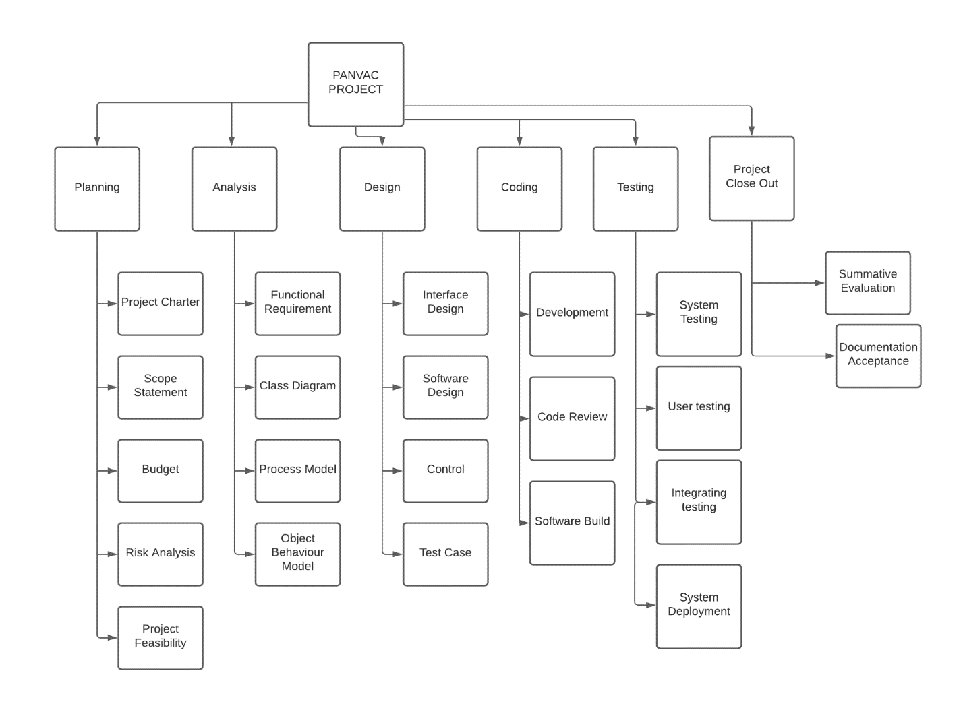

**Implementation:**

|  |  |  |  |  |  |
| --- | --- | --- | --- | --- | --- |
| **Task Name** | **Predecessor** | **Effort** | **Estimated**  **Start Date** | **Estimated End Date** | **Assigned Resource(s)** |
| **1.0 Planning** |  |  |  |  |  |
| 1.1 Project Charter | 1.0 | 1 day | 2/02/21 | 2/03/21 | Sreejaya |
| 1.2 Scope Statement | 1.0 | 3 days | 2/03/21 | 2/06/21 | Sreejaya |
| 1.3 Budget | 1.0 | 3 days | 2/07/21 | 2/1021 | Sreejaya |
| 1.4 Risk Analysis | 1.2 | 2 days | 2/11/21 | 2/13/21 | Sreejaya |
| 1.5 Project Feasibility | 1.3 | 2 days | 2/15/21 | 2/17/21 | Sreejaya |
| **2.0 Analysis** |  |  |  |  |  |
| 2.1 Functional Requirement | 1.4 | 1 day | 2/17/21 | 2/18/21 | Lakshit,Meenal, Prabhavi |
| 2.2 Class Diagram | 2.1 | 1 day | 2/18/21 | 2/19/21 | Lakshit,Meenal, Prabhavi |
| 2.3 Process Model | 2.2 | 1 day | 2/19/21 | 2/20/21 | Lakshit,Meenal, Prabhavi |
| 2.4 Object Behaviour Model | 2.2 | 2 days | 2/20/21 | 2/22/21 | Lakshit,Meenal, Prabhavi |
| **3.0 Design** | **2.0** |  |  |  |  |
| 3.1 Interface Design | 2.4 | 5 days | 2/23/21 | 2/28/21 | Lakshit,Meenal, Prabhavi |
| 3.2 Software design | 3.1 | 5 days | 3/28/21 | 3/05/21 | Lakshit,Meenal, Prabhavi |
| 3.3 Controls | 3.2 | 4 days | 3/06/21 | 3/10/21 | Lakshit,Meenal, Prabhavi |
| 3.4 Test Cases | 3.3 | 4 days | 3/11/21 | 3/15/21 | Lakshit,Meenal, Prabhavi |
| **4. Coding** |  |  |  |  |  |
| 4.1 Development | 3.3 | 3 days | 3/15/21 | 3/15/21 | Lakshit,Meenal, Prabhavi |
| 4.2 Code Review | 4.1 | 3 days | 3/15/21 | 3/15/21 | Lakshit,Meenal, Prabhavi |
| 4.3 Software Build | 4.2 | 3 days | 3/15/21 | 3/15/21 | Lakshit,Meenal, Prabhavi |
| **5.Testing** |  |  |  |  |  |
| 5.1 System Testing | 4.3 | 5 days | 3/15/21 | 3/15/21 | Mariya,Debshila |
| 5.2 User Testing | 5.1 | 2 days | 3/15/21 | 3/15/21 | Mariya,Debshila |
| 5.3 Integrating Testing | 5.2 | 2 days | 3/15/21 | 3/15/21 | Mariya,Debshila |
| 5.4 System Deployment | 5.3 | 2 days | 3/15/21 | 3/15/21 | Mariya,Debshila |
| **6.0 Implementation** |  |  |  |  |  |
| 6.1 Application Setup | 5.0 | 1 Days | 3/15/21 | 3/16/21 | Lakshit |
| 6.2 Maintenance | 6.1 | 1 day | 3/16/21 | 3/17/21 | Lakshit |

**Work Breakdown Structure Dictionary:**

|  |  |  |
| --- | --- | --- |
| **WBS Code** | **WBS Name** | **WBS Description** |
| 2.3 | Process Model | Creation of Use Case Diagrams. |
| 2.2 | Object Behaviour Model | Creation of Sequence Diagram. |
| 3.1  3.2 | Interface Design  Software Design | Design of the application user interface, which allows interaction with the parking map.  Design of the application software necessary to implement the parking map and integrate it with existing sensors |

Meeting Minutes

|  |  |  |  |
| --- | --- | --- | --- |
| Meeting Date | 02/01/2021 | Meeting Location | MS TEAM |
| Meeting Time | 8:00 PM | Meeting Title | Project Proposal |
| Attendees | Meenal Badki; Debshila Bhattacharya; Mariya Khalid; Sreejaya Parameswaran; Lakshit Rajput; Prabhavi Soni | | |

Meeting 1:

|  |
| --- |
| Brief Description / Agenda |
| * Discuss about the project proposal * Scope of the project * Timeline and next step |

|  |  |  |  |
| --- | --- | --- | --- |
| Meeting Date | 02/15/2021 | Meeting Location | MS TEAM |
| Meeting Time | 6:00 PM | Meeting Title | Project Proposal Milestone 2 |
| Attendees | Meenal Badki; Debshila Bhattacharya; Mariya Khalid; Sreejaya Parameswaran; Lakshit Rajput; Prabhavi Soni | | |

Meeting 2:

|  |
| --- |
| Brief Description / Agenda |
| * Discuss about project planning and analysis. * Discuss about the project objectives. * Timeline and next step |

|  |  |  |  |
| --- | --- | --- | --- |
| Meeting Date | 02/22/2021 | Meeting Location | MS TEAM |
| Meeting Time | 6:00 PM | Meeting Title | Project Proposal Milestone 2 |
| Attendees | Meenal Badki; Debshila Bhattacharya; Mariya Khalid; Sreejaya Parameswaran; Lakshit Rajput; Prabhavi Soni | | |

Meeting 3:

|  |
| --- |
| Brief Description / Agenda |
| * + - Discuss and draft the Milestone 2     - Discuss and draft the Work Breakdown Structure     - Confirm the scope analysis     - Allocate tasks to group members |